Assignment-02

Name: Rupsa Mukhopadhyay Date:20th Nov,2021

Roll.no: 21052094

Section: B20

Branch: CSE

1. WAP to give 60 marks grace if age is below 50 else gives 40 marks grace.

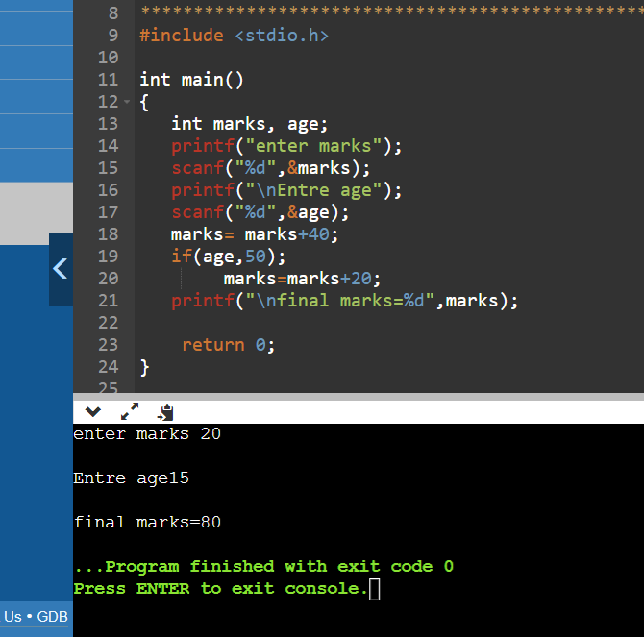

1. WAP to print "KIIT student" if u r in class 1 to 12 else print "KIIT University student".

Assignment-02

Name: Rupsa Mukhopadhyay Date:20th Nov,2021

Roll.no: 21052094

Section: B20

Branch: CSE

1. WAP to give 60 marks grace if age is below 50 else gives 40 marks grace.



1. WAP to print "KIIT student" if u r in class 1 to 12 else print "KIIT University student".

Assignment-02

Name: Rupsa Mukhopadhyay Date:20th Nov,2021

Roll.no: 21052094

Section: B20

Branch: CSE

1. WAP to give 60 marks grace if age is below 50 else gives 40 marks grace.



1. WAP to print "KIIT student" if u r in class 1 to 12 else print "KIIT University student".

Assignment-02

Name: Rupsa Mukhopadhyay Date:20th Nov,2021

Roll.no: 21052094

Section: B20

Branch: CSE

1. WAP to give 60 marks grace if age is below 50 else gives 40 marks grace.



1. WAP to print "KIIT student" if u r in class 1 to 12 else print "KIIT University student".

Assignment-02

Name: Rupsa Mukhopadhyay Date:20th Nov,2021

Roll.no: 21052094

Section: B20

Branch: CSE

1. WAP to give 60 marks grace if age is below 50 else gives 40 marks grace.



1. WAP to print "KIIT student" if u r in class 1 to 12 else print "KIIT University student".

Assignment-02

Name: Rupsa Mukhopadhyay Date:20th Nov,2021

Roll.no: 21052094

Section: B20

Branch: CSE

1. WAP to give 60 marks grace if age is below 50 else gives 40 marks grace.



1. WAP to print "KIIT student" if u r in class 1 to 12 else print "KIIT University student".

Assignment-02

Name: Rupsa Mukhopadhyay Date:20th Nov,2021

Roll.no: 21052094

Section: B20

Branch: CSE

1. WAP to give 60 marks grace if age is below 50 else gives 40 marks grace.



1. WAP to print "KIIT student" if u r in class 1 to 12 else print "KIIT University student".

Assignment-02

Name: Rupsa Mukhopadhyay Date:20th Nov,2021

Roll.no: 21052094

Section: B20

Branch: CSE

1. WAP to give 60 marks grace if age is below 50 else gives 40 marks grace.



1. WAP to print "KIIT student" if u r in class 1 to 12 else print "KIIT University student".

Assignment-02

Name: Rupsa Mukhopadhyay Date:20th Nov,2021

Roll.no: 21052094

Section: B20

Branch: CSE

1. WAP to give 60 marks grace if age is below 50 else gives 40 marks grace.



1. WAP to print "KIIT student" if u r in class 1 to 12 else print "KIIT University student".

Assignment-02

Name: Rupsa Mukhopadhyay Date:20th Nov,2021

Roll.no: 21052094

Section: B20

Branch: CSE

1. WAP to give 60 marks grace if age is below 50 else gives 40 marks grace.



1. WAP to print "KIIT student" if u r in class 1 to 12 else print "KIIT University student".

Assignment-02

Name: Rupsa Mukhopadhyay Date:20th Nov,2021

Roll.no: 21052094

Section: B20

Branch: CSE

1. WAP to give 60 marks grace if age is below 50 else gives 40 marks grace.



1. WAP to print "KIIT student" if u r in class 1 to 12 else print "KIIT University student".

Assignment-02

Name: Rupsa Mukhopadhyay Date:20th Nov,2021

Roll.no: 21052094

Section: B20

Branch: CSE

1. WAP to give 60 marks grace if age is below 50 else gives 40 marks grace.



1. WAP to print "KIIT student" if u r in class 1 to 12 else print "KIIT University student".

Assignment-02

Name: Rupsa Mukhopadhyay Date:20th Nov,2021

Roll.no: 21052094

Section: B20

Branch: CSE

1. WAP to give 60 marks grace if age is below 50 else gives 40 marks grace.



1. WAP to print "KIIT student" if u r in class 1 to 12 else print "KIIT University student".

Assignment-02

Name: Rupsa Mukhopadhyay Date:20th Nov,2021

Roll.no: 21052094

Section: B20

Branch: CSE

1. WAP to give 60 marks grace if age is below 50 else gives 40 marks grace.



1. WAP to print "KIIT student" if u r in class 1 to 12 else print "KIIT University student".

Assignment-02

Name: Rupsa Mukhopadhyay Date:20th Nov,2021

Roll.no: 21052094

Section: B20

Branch: CSE

1. WAP to give 60 marks grace if age is below 50 else gives 40 marks grace.



1. WAP to print "KIIT student" if u r in class 1 to 12 else print "KIIT University student".

Assignment-02

Name: Rupsa Mukhopadhyay Date:20th Nov,2021

Roll.no: 21052094

Section: B20

Branch: CSE

1. WAP to give 60 marks grace if age is below 50 else gives 40 marks grace.



1. WAP to print "KIIT student" if u r in class 1 to 12 else print "KIIT University student".

Assignment-02

Name: Rupsa Mukhopadhyay Date:20th Nov,2021

Roll.no: 21052094

Section: B20

Branch: CSE

1. WAP to give 60 marks grace if age is below 50 else gives 40 marks grace.



1. WAP to print "KIIT student" if u r in class 1 to 12 else print "KIIT University student".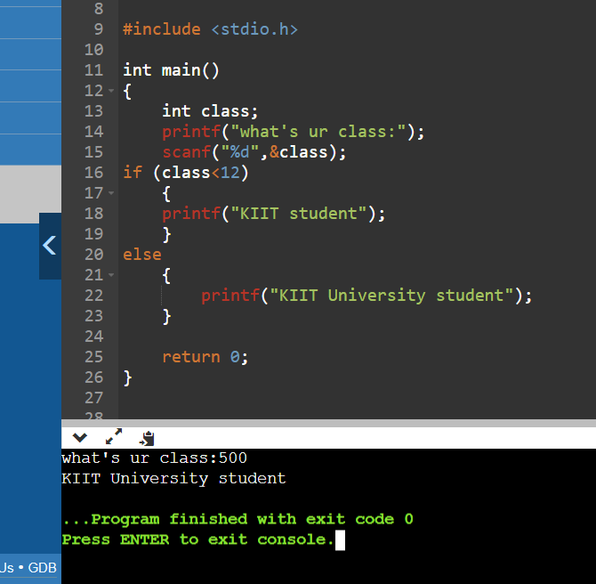
2. WAP to display whether the Wheatstone bridge is balanced or not if not find out value of the variable resistance to balance the bridge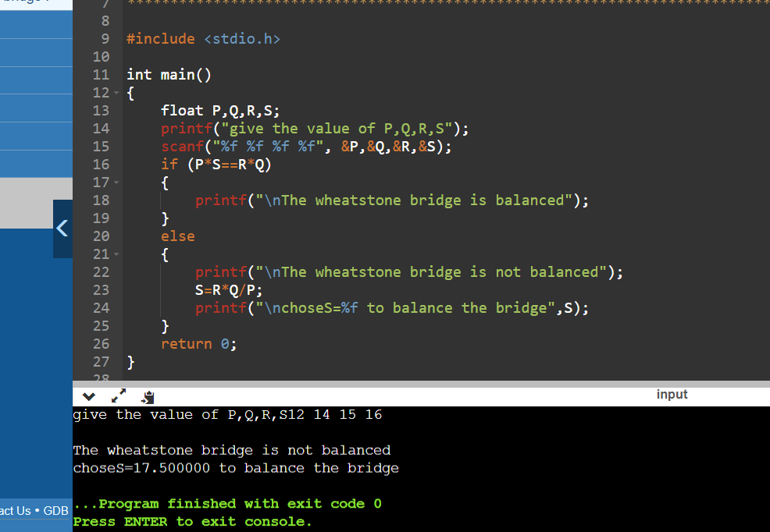



1. WAP to the greatest no , if four nos. a, b, c, d is given.

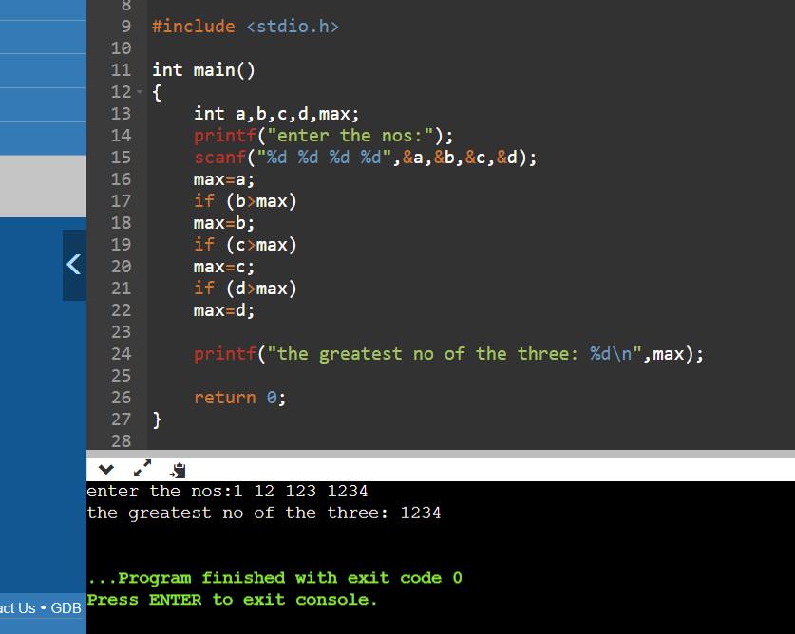

1. If basic salary is<$1500 then HRA=10% and DA= 40% of basic salary else HRA= $500 and DA=50% of salary. WAP to find his gross salary.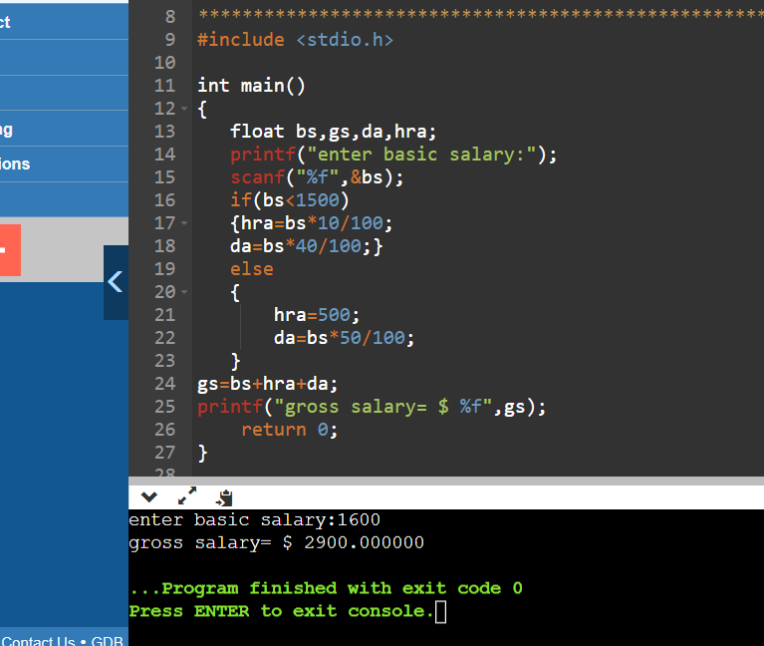
2. If basic salary is<$1500 then HRA=10% and DA= 40% of basic salary else HRA= $500 and DA=50% of salary. WAP to find his gross salary. style 2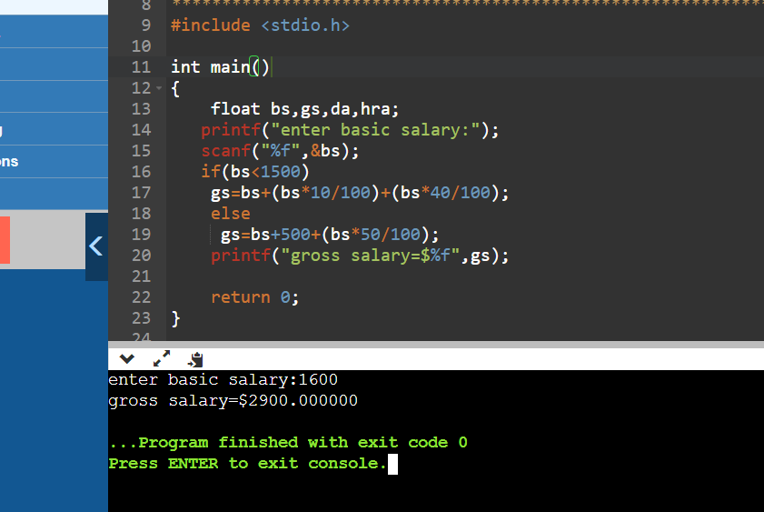
3. given 3 points {(x1,y1),(x2,y2),(x3,y3)} in 2-D, display whether they form a triangle or not.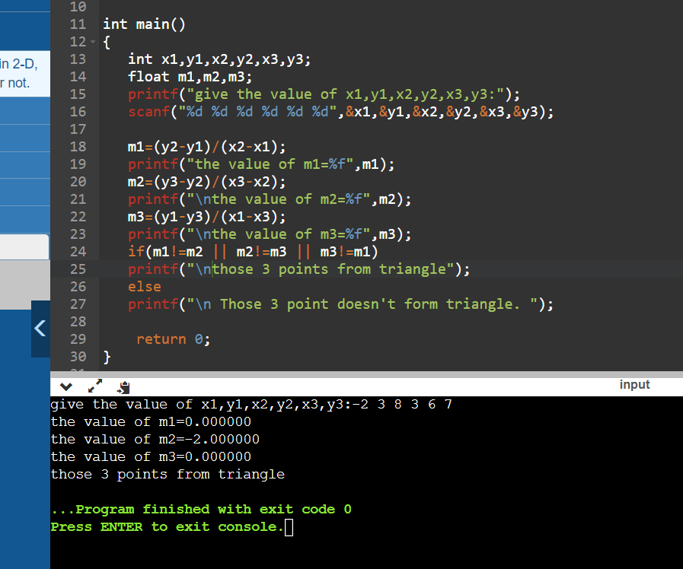
4. WAP to display the position ,size, and type of image formed by a concave mirror.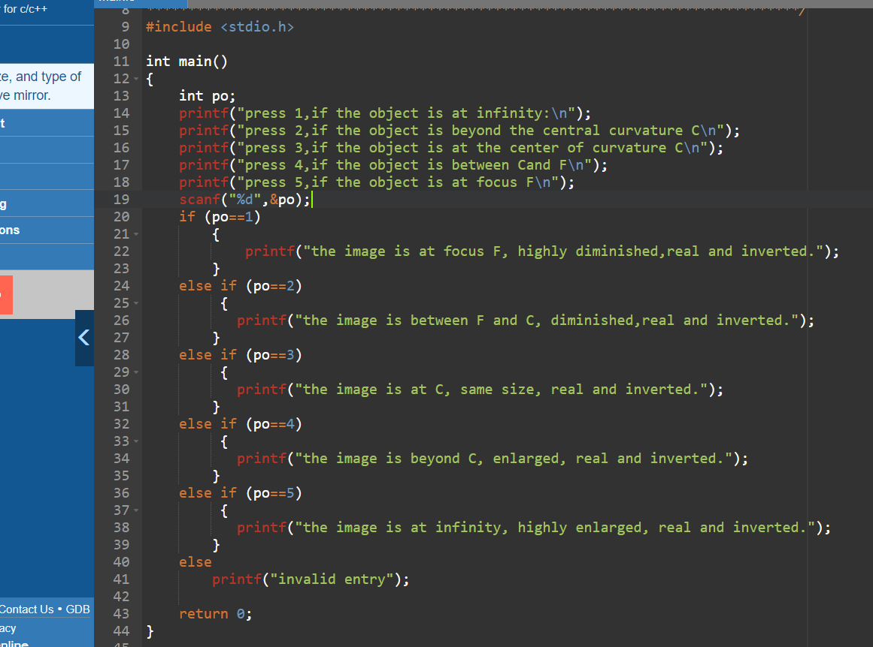

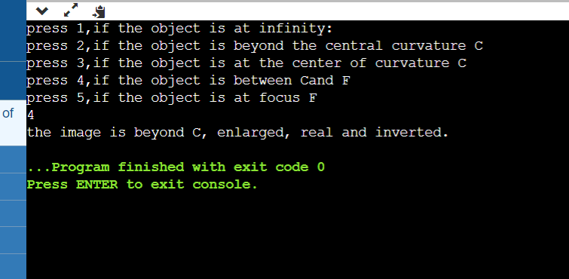

1. WAP to check if user name and password correct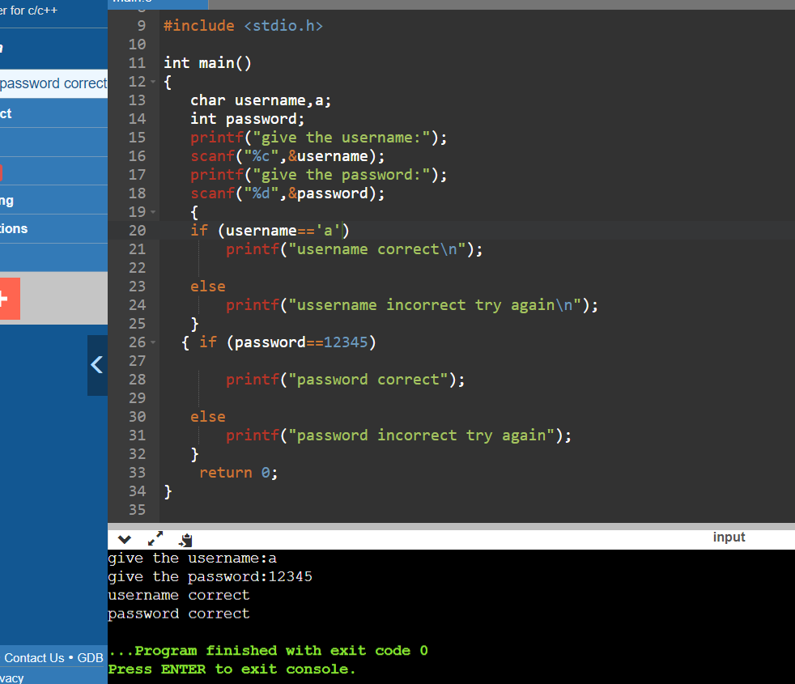
2. declaring grade of a student 1st division(>59) 2nd(>49) 3rd(>39) fail(<40)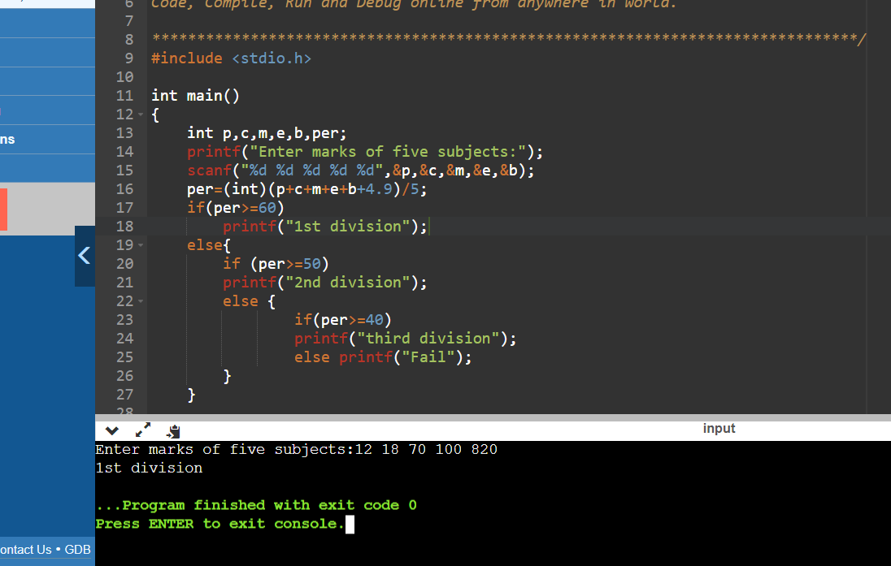
3. WAP to find if a,b,c are sides of a triangle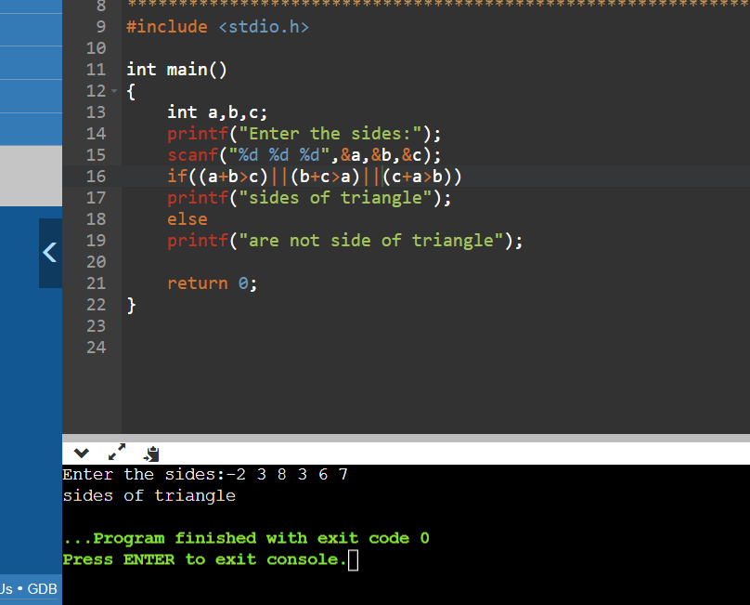
4. score of 10 cricket player and find the no. of century 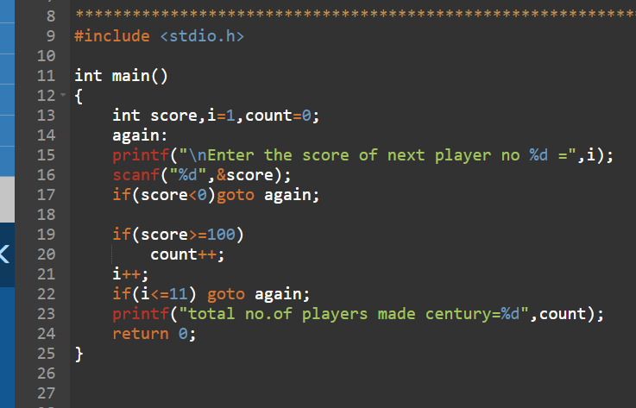

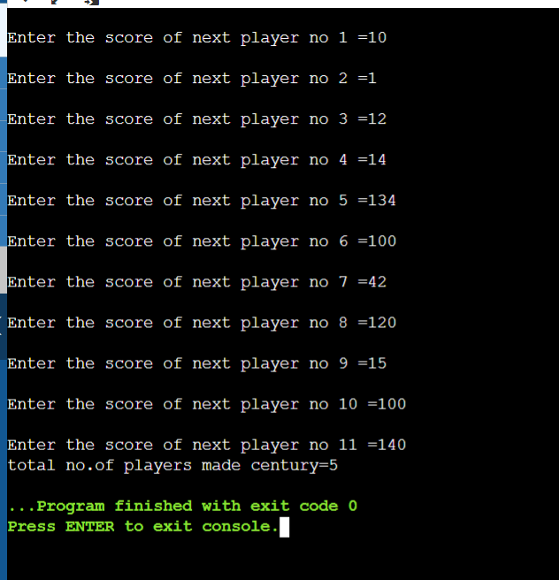

1. WAP to find the root of quadratic equation by using the coefficient.

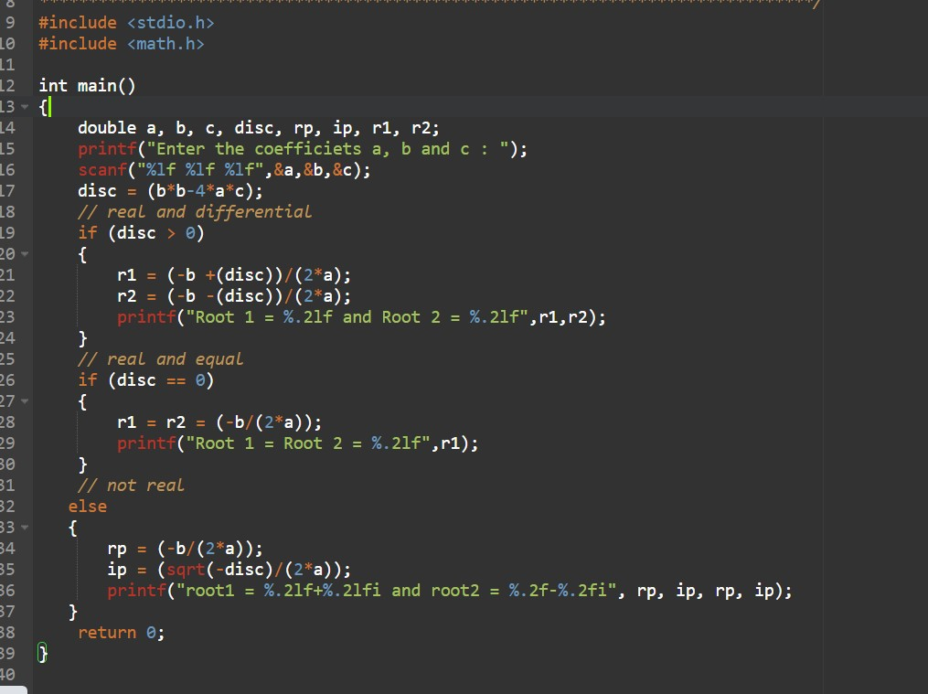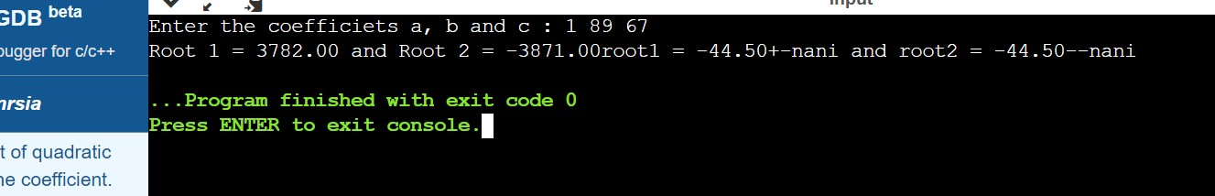

1. WAP to find the reverse of positive integers and to check for Palindrome or not.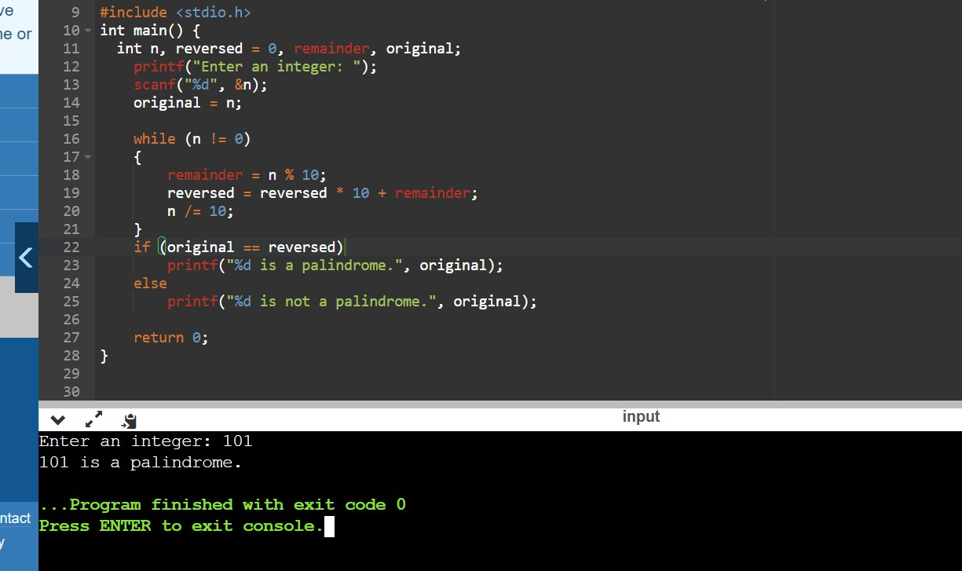
2. WAP to input a number and check if the no. Is prime or not

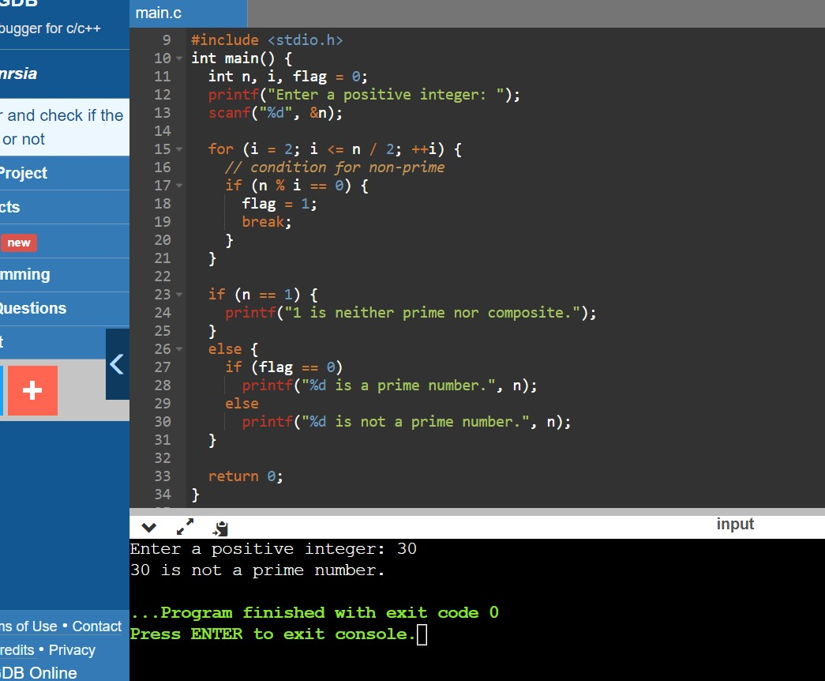

1. WAP to find th total score and avg score

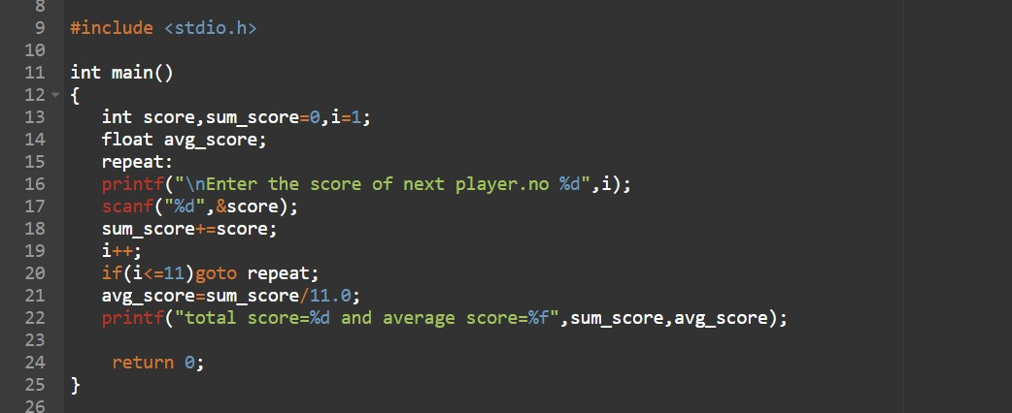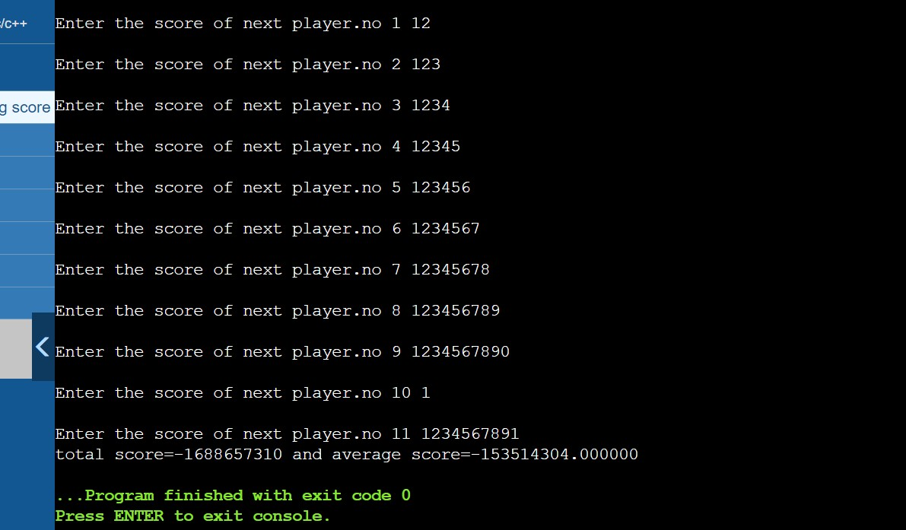

1. WAP to display nos 1 to 9 on the screen in different lines. 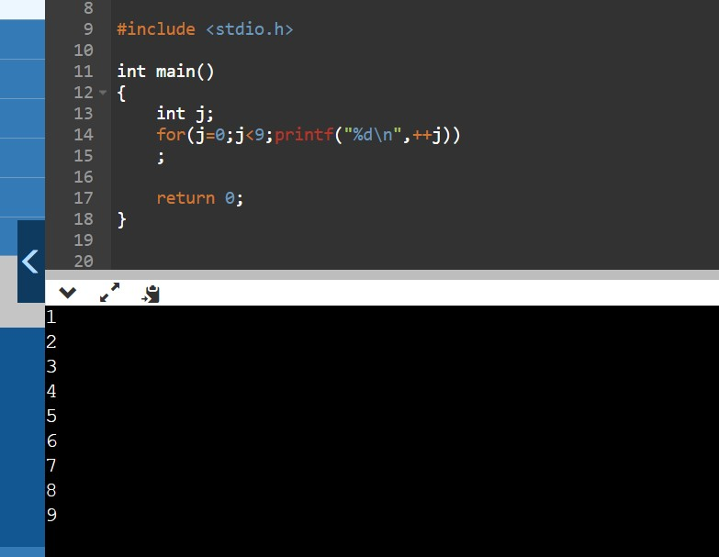
2. enter 10 numbers from k/b and count number of old numbers and find their sum(odd numbers).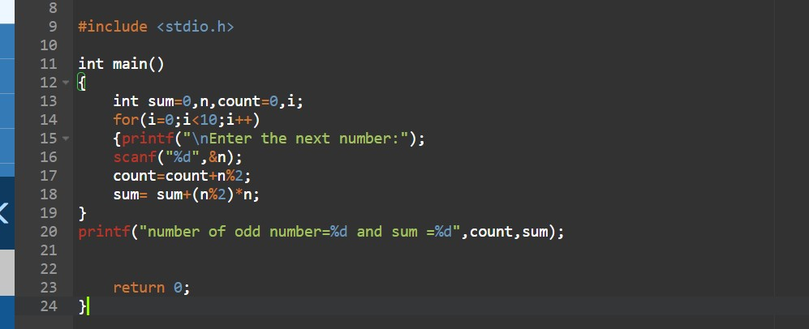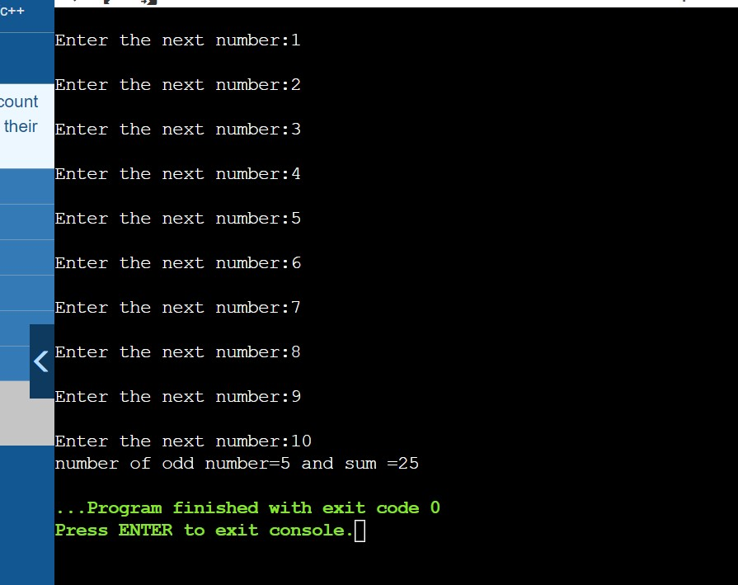
3. Pendulum.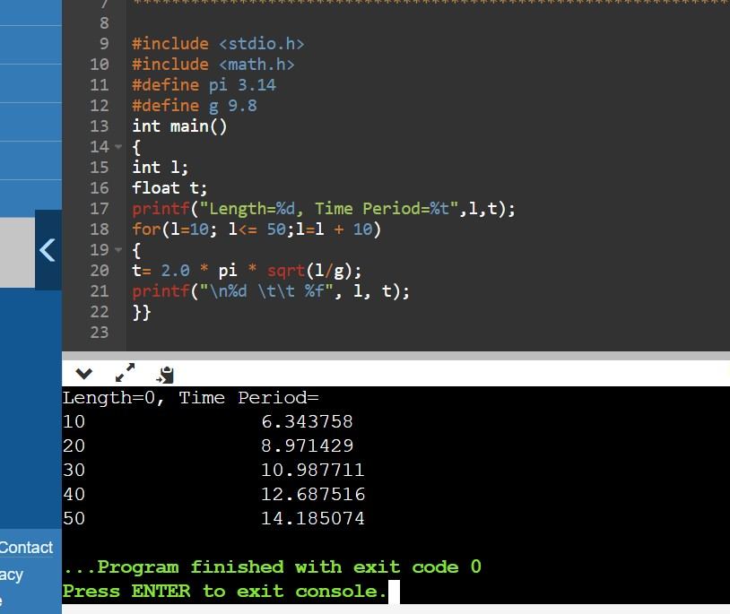
4. WAP to input a no. check whether the no is armstrong or not. 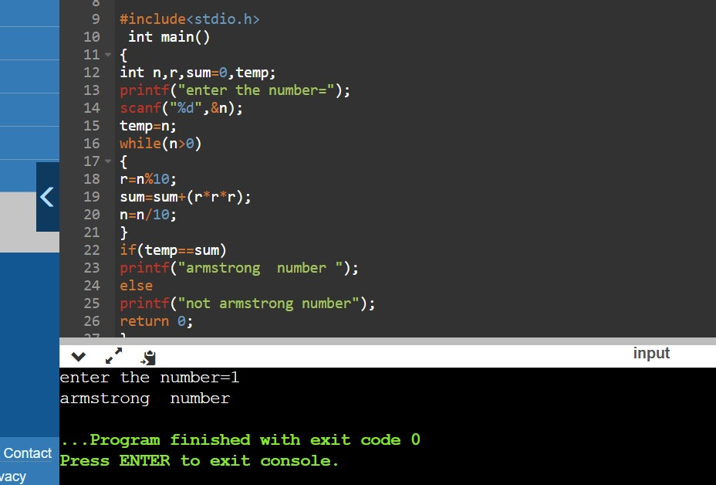
5. WAP to input a no. check whether the no is perfect or not.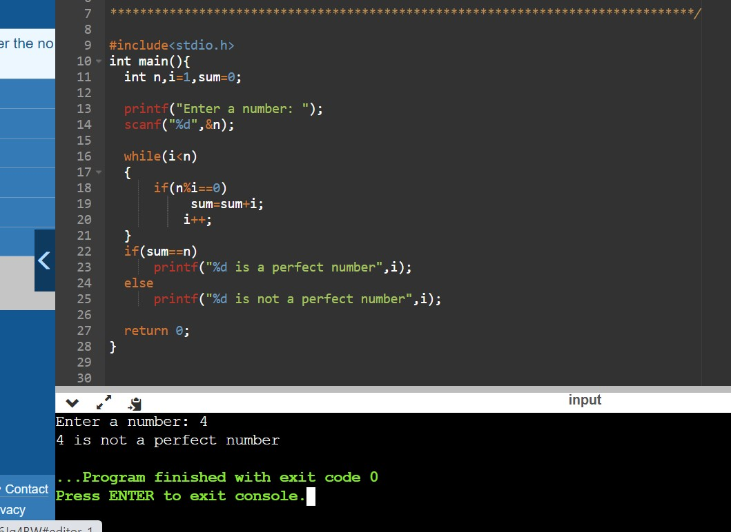
6. palindrome with loop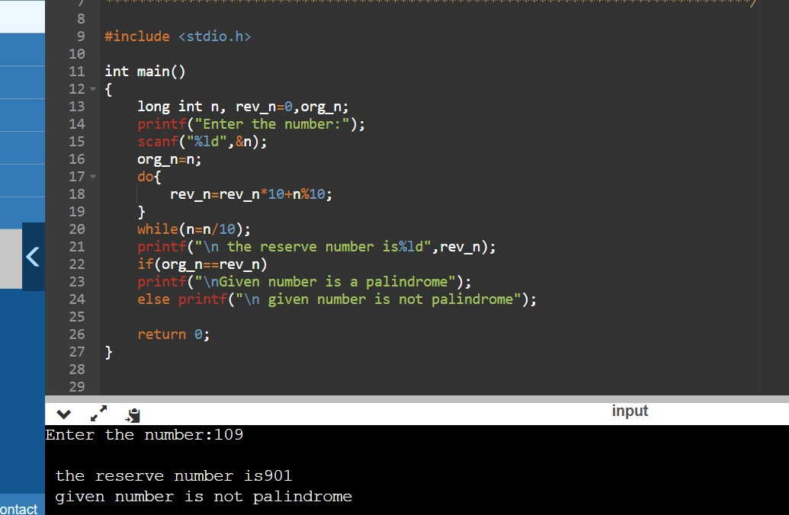
7. WAP to print and count all the palindromic nos b/w 1 to 1000 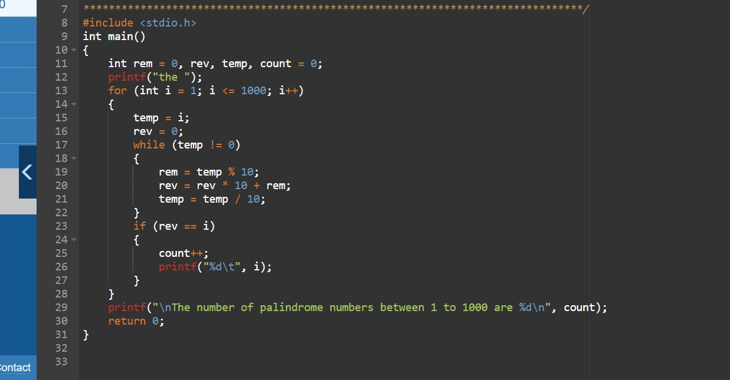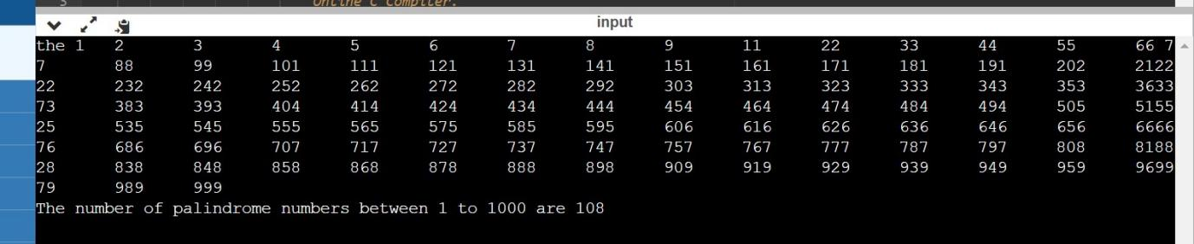
8. Matchstick game. 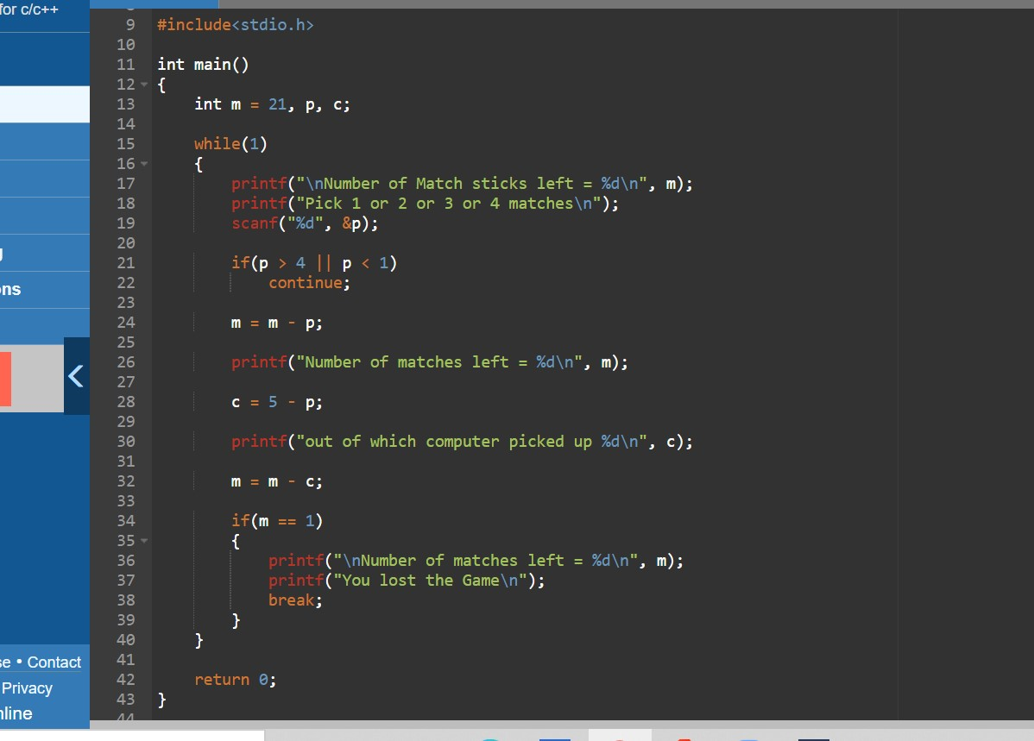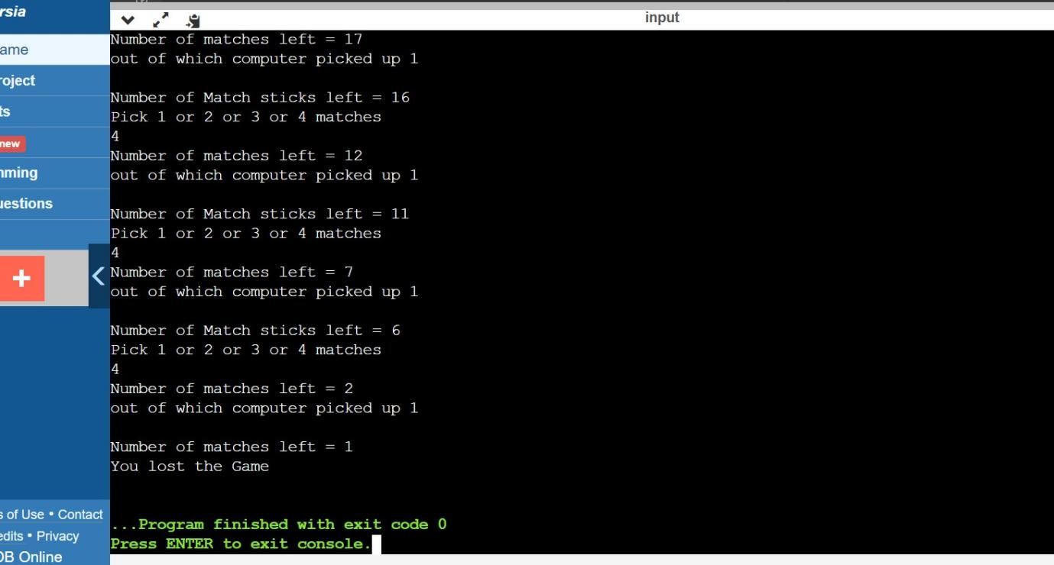
9. decimal to binary by function. 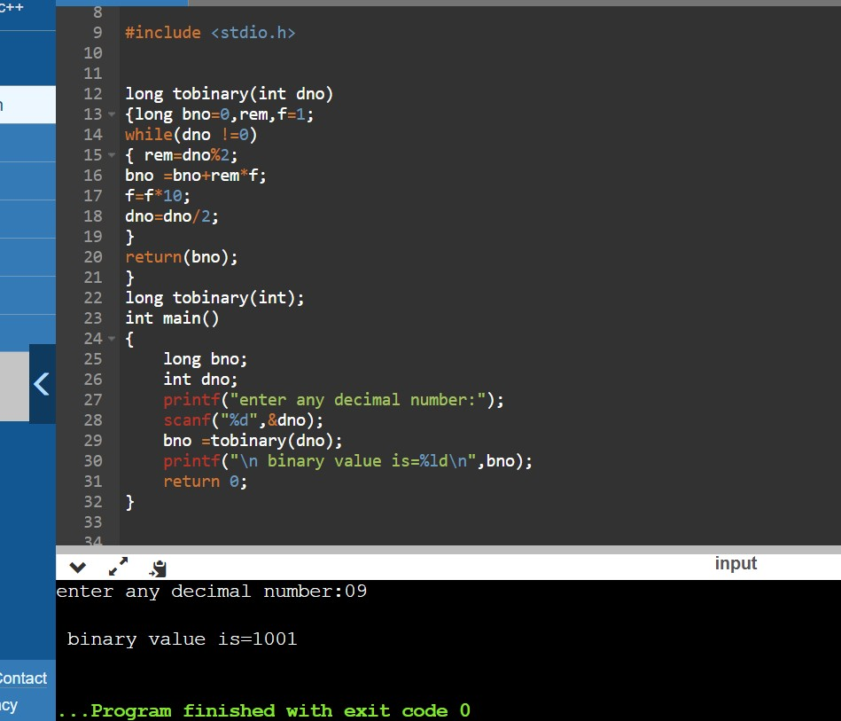
10. decimal to octal 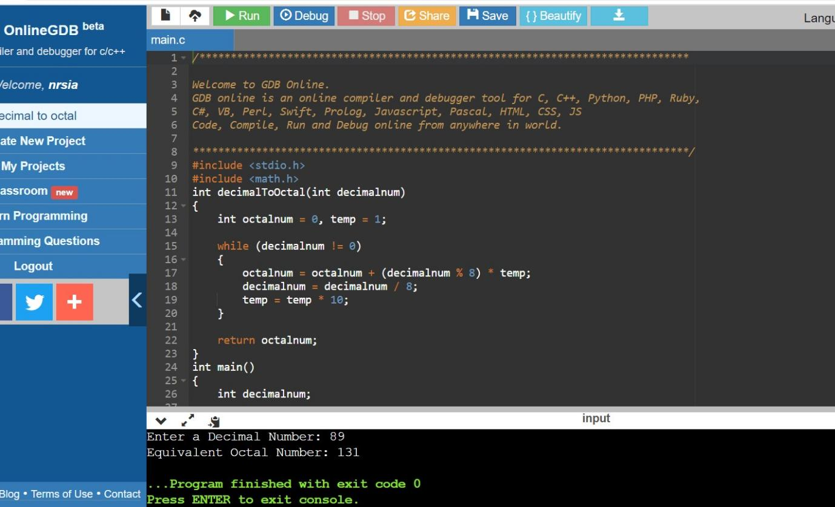
11. octal to binary 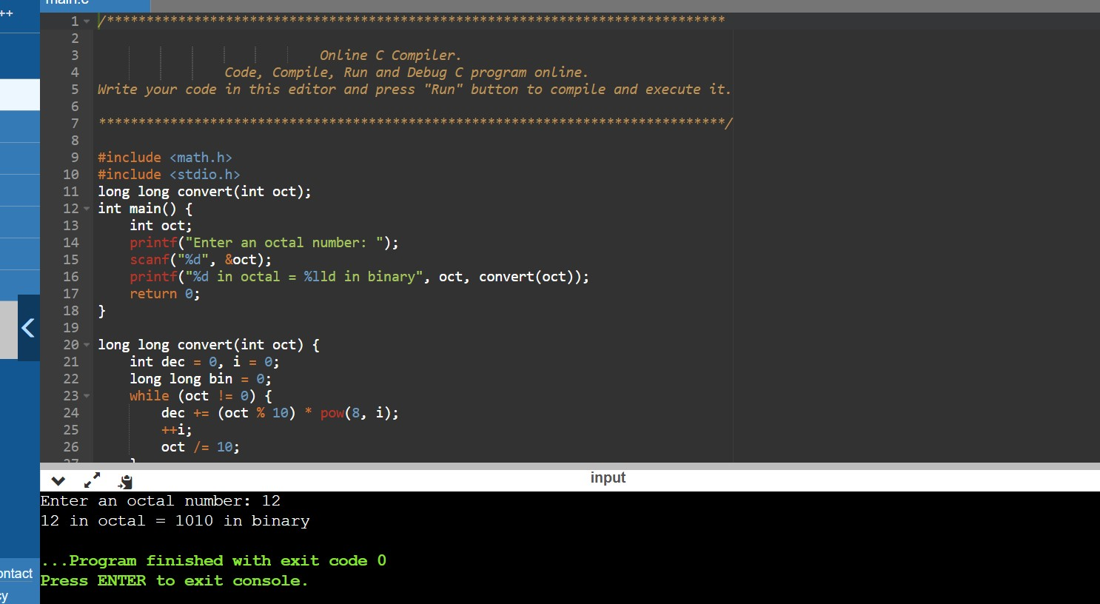
12. Binary to octal. 